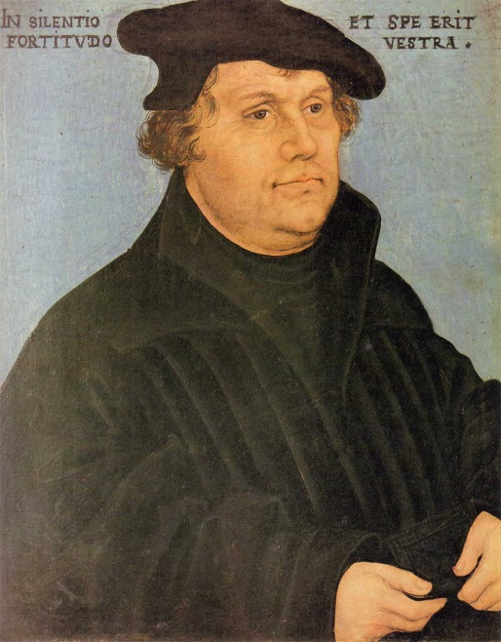

**Luther-spillet fra**

**Navn på gruppa:**

**Foto: Wikimedia commons**

|  |  |
| --- | --- |
| **RUTE 1** | |
| **SPØRSMÅL** | **SVAR** |
| **1:** | **1:** |
| **2:** | **2:** |
| **3:** | **3:** |
| **4:** | **4:** |

|  |  |
| --- | --- |
| **RUTE 2** | |
| **SPØRSMÅL** | **SVAR** |
| **1:** | **1:** |
| **2:** | **2:** |
| **3:** | **3:** |
| **4:** | **4:** |

|  |  |
| --- | --- |
| **RUTE 3** | |
| **SPØRSMÅL** | **SVAR** |
| **1:** | **1:** |
| **2:** | **2:** |
| **3:** | **3:** |
| **4:** | **4:** |

|  |  |
| --- | --- |
| **RUTE 4** | |
| **SPØRSMÅL** | **SVAR** |
| **1:** | **1:** |
| **2:** | **2:** |
| **3:** | **3:** |
| **4:** | **4:** |

|  |  |
| --- | --- |
| **RUTE 5** | |
| **SPØRSMÅL** | **SVAR** |
| **1:** | **1:** |
| **2:** | **2:** |
| **3:** | **3:** |
| **4:** | **4:** |

|  |  |
| --- | --- |
| ***RUTE 6*** | |
| ***SPØRSMÅL*** | ***SVAR*** |
| ***1:*** | ***1:*** |
| ***2:*** | ***2:*** |
| ***3:*** | ***3:*** |
| ***4:*** | ***4:*** |

|  |  |
| --- | --- |
| **RUTE 7** | |
| **SPØRSMÅL** | **SVAR** |
| **1:** | **1:** |
| **2:** | **2:** |
| **3:** | **3:** |
| **4:** | **4:** |

|  |  |
| --- | --- |
| **RUTE 8** | |
| **SPØRSMÅL** | **SVAR** |
| **1:** | **1:** |
| **2:** | **2:** |
| **3:** | **3:** |
| **4:** | **4:** |

|  |  |
| --- | --- |
| **RUTE 9** | |
| **SPØRSMÅL** | **SVAR** |
| **1:** | **1:** |
| **2:** | **2:** |
| **3:** | **3:** |
| **4** | **4:** |

|  |  |
| --- | --- |
| **RUTE 10** | |
| **SPØRSMÅL** | **SVAR** |
| **1:** | **1:** |
| **2:** | **2:** |
| **3:** | **3:** |
| **4:** | **4:** |

Gratulerer!

Dere har gjennomført Luther-spillet og er nå snart Luther-eksperter!